**RESTAURANT MANAGEMENT SYSTEM - HOTEL RESERVATION SYSTEM**

**RMS**

**- TABLE RESERVATION**

**- FOOD ITEMS [DINING - TAKE AWAY - ONLINE ORDER]**

**- FOOD ITEMS WITH PRICE LIST [ BREAKFAST,LUNCH,DINNER,SNACKS] [DINING - PARCEL ]**

**- WORKERS [ NO..OF EMPLOYEES, EMPLOYEE NAME, DESIGNATION, ATTENDANCE,SALARY]**

**- WORKERS SALARY [DAY BASIS, WEEK BASIS, MONTHLY BASIS ]**

**- STOCK [ AVAILABLE FURNITURES ]**

**- ACCOUNTS [ CUSTOMERS, EXPENSES - PURCHASE GROCERIES, WORKER SALARY, EB BIL, ADVERTISEMENT, GAS BILL]**

**- BILLING [ ONLINE - CASH BILL -CREDIT CARD /DEBIT CARD ] [BILL NO.] [ GST CALCULATION]**

**- PARKING CHARGES**

**- KITCHEN MAINTENANCE [VESSELS]**

|  |  |  |  |  |  |
| --- | --- | --- | --- | --- | --- |
| **S.NO** | **FOOD** | **ACCOUNTS** | **STOCK** | **WORKERS** | **GENERAL** |
| **1** | **DINING - OVER** | **DAILY INCOME [CUSTOMER]** | **FURNITURES** | **DETAILS** | **PARKING** |
| **2** | **CASH / CARD BILL - OVER** | **DAILY EXPENSES [ - OVER** | **FAN** | **, WORKER SALARY** | **REPORTS** |
| **3** | **FOOD ITEMS [ MENU CARD - BF,LUN,DINN] - OVER** | **GROCERIES - OVER, EB BIL - OVER, , GAS BILL - OVER]** | **AC** | **ATTENDANCE** | **- FOOD DELIVERY** |
| **4** | **FOOD ITEMS WITH PRICE- OVER** | **BILLING WITH GST - OVER** | **TABLE, CHAIR** | **POSITION WISE** | **- NO.OF CUSTOMERS VISIT** |
| **5** | **ONLINE ORDER DELIVERY [ID]** | **ADVERTISEMENT** | **VESEEL MAINTENANCE** | **MODE OF SALARY** | **- SALE OF FOOD ITEMS** |
|  |  |  |  |  | **- REVIEWS** |
| **6** | **AC DINING HALL - OVER** |  |  |  | **DISPOSABLE FOODS** |
| **7** | **TABLE RESERVATION - OVER** |  |  |  |  |
|  |  |  |  |  |  |

**HRS**

**- ROOM BOOKING [SINGLE/DOUBLE/FAMILY] [AC/NON AC] - OVER**

**- ROOM CANCELLATION - OVER**

**- ROOM MAINTENEANCE - OVER**

**- BAR [ATTACHED]**

**- RECEPTION**

|  |  |  |  |  |
| --- | --- | --- | --- | --- |
| **HANAS AHAMED** | **MOHAMMED HAKKIM** | **INBARAJ** | **PRASANTH** | **PADMAVATHI** |
| HOTEL BOOKING | FOOD MODULE | ACCOUNTS | WORKERS -GENERAL | STOCK DETAILS |
| - ROOM BOOKING FORM | - FOOD ITEMS ENTRY WITH PRICE | - EXPENSES ENTRY FORM | WORKERS APPLICATION FORM | STOCK ENTRY FORM |
| - ROOM CANCELLATION FORM | - DINING - PARCEL | - GROCERIES ENTRY FORM |  | PARKING ENTRY |
|  |  | - VESSELS ENTRY FORM |  |  |

|  |
| --- |
| **HANAS AHAMED** |
| HOTEL BOOKING |
| - HOTEL BOOKING FORM |

RECEPTION

1. CUSTOMER VISIT PER DAY
2. PHONE CALLS FROM ROOMS
3. REQUIREMENTS FROM ROOMS
4. ALLOCATE WAITER TO ROOMS
5. AVAILABLE ROOMS INFO
6. ROOM CHANGE
7. PHONE CALLS FROM OUTSIDE
8. DAILY REPORT TO MANAGER

BAR

1. STOCKS AVAILABILITY WITH BRANDS
2. TABLE DINING
3. WAITER ALLOCATE TO TABLE
4. SIDE DISH
5. NATURE OF SIDE DISH
6. DATE OF ENTRY

ROOM BOOKING FORM

1. NAME OF THE CUSTOMER
2. DATE OF BIRTH
3. AGE
4. GENDER
5. ADDRESS [DOOR NO,STREETNAME,FLAT NAME,AREA NAME, DISTRICT, STATE, PINCODE]
6. PROOF [AADHAR/PAN/VOTERID/LICENSE/SMARTCARD]
7. NO. OF PERSONS [ CHILDRENS, ADULT, AGED]
8. NO. OF ROOMS [SINGLE/DOUBLE]
9. HOW MANY DAYS YOU STAY [1/2/3/4]
10. MOBILE NUMBER
11. EMAIL ID
12. DATE OF BOOKING
13. DATE OF VACATE
14. SIGNATURE
15. RULES
16. RELATIONSHIP
17. AC ROOM, NON AC ROOM

**ROOM CANCELLATION FORM**

1. NAME OF THE CUSTOMER
2. ADDRESS [DOOR NO,STREETNAME,FLAT NAME,AREA NAME, DISTRICT, STATE, PINCODE]
3. PROOF [AADHAR/PAN/VOTERID/LICENSE/SMARTCARD]
4. NO. OF PERSONS [ CHILDRENS, ADULT, AGED]
5. NO. OF ROOMS [SINGLE/DOUBLE]
6. HOW MANY DAYS YOU STAY [1/2/3/4]
7. MOBILE NUMBER
8. EMAIL ID
9. DATE OF CANCELLATION [FROM TO]
10. SIGNATURE
11. RULES
12. RELATIONSHIP
13. AC ROOM, NON AC ROOM
14. ROOM NUMBER
15. NO. OF DAYS

**ROOM MAINTENANCE**

1. AC ROOM NON AC ROOM

2. BEDS [SINGLE,DOUBLE,EXTRA]

3. ROOM NO

4. PILLOWS VERIFYING

5. BEDSHEET VERIFINY

6,. REST ROOM CLEANING

7. WATER

8. TV

9. PHONE

10. AC CHCKING

11. FURNITURE CHECKING

|  |
| --- |
| **MOHAMMED HAKKIM** |
| FOOD MODULE |
| - FOOD ITEMS ENTRY WITH PRICE |

**FOOD ITEMS ENTRY WITH PRICE**

1. **SNO**
2. **NAME OF THE FOOD**
3. **FOOD CATEGORY [ BREAKFAST,LUNCH,DINNER]**
4. **PRICE OF THE FOOD**
5. **DATE OF ENTRY**

**BILLNG**

1. **BILL NO**
2. **ITEM NAME**
3. **QUANTITY**
4. **PRICE**
5. **TOTAL**
6. **GST [18%]**
7. **NET TOTAL**
8. **MODE OF PAYMENT [CASH/CARD/UPI]**

**DINING:**

1. **TABLE NO**
2. **FOOD ORDERED TO PARTICULAR TABLE**
3. **WAITER ALLOCATION**

PARCEL:

1. **BILL NO**
2. **NATURE OF ITEMS WITH QUANTITY AND PRICE**
3. **DATE**
4. **TIME**
5. **TIME SAVING**
6. **TOTAL AMOUNT**
7. **GST**
8. **PARCEL HANDOVER TO CUSTOMER**
9. **PACKING CHARGES**
10. **PACKING WAITER NAME**

|  |
| --- |
| **INBARAJ** |
| ACCOUNTS |
| - EXPENSES ENTRY FORM |

**EXPENSES ENTRY FORM**

1. **s no**
2. **particulars**
3. **amount**

**INCOME ENTRY FORM [HOTEL]**

1. **s no**
2. **particulars [HOTEL - ROOM BOOKING]**
3. **amount**
4. **DATE**

**INCOME ENTRY FORM [RMS]**

1. **s no**
2. **particulars [BILL OF INCOME]**
3. **amount**
4. **DATE**

|  |
| --- |
| **ADVERTISEMENT** |

1. **SOCIAL MEDIA**
2. **NOTICES**
3. **BROCHURES**
4. **POSTERS**
5. **NEWSPAPERS AD**
6. **VEHICLE AD**
7. **TV AD**
8. **RADIO AD**

**GROCERIES ENTRY FORM**

1. **SNO**
2. **DATE**
3. **NATURE OF GROCERIES**
4. **QTY**
5. **PRICE**
6. **TOTAL**
7. **GRAND TOTAL**
8. **TAX**
9. **NET TOTAL**

**GAS MAINTENACE FORM**

1. **S.NO**
2. **GAS NO. [INDIVIDUAL]**
3. **GAS TAKING DATE**
4. **NUMBER OF GASES TAKEN**
5. **GAS EMPTY DATE**
6. **GASES AVAILABLE**
7. **GAS COMPANY NAME**
8. **GAS COMPANY CONTACT**
9. **GAS AMOUNT**

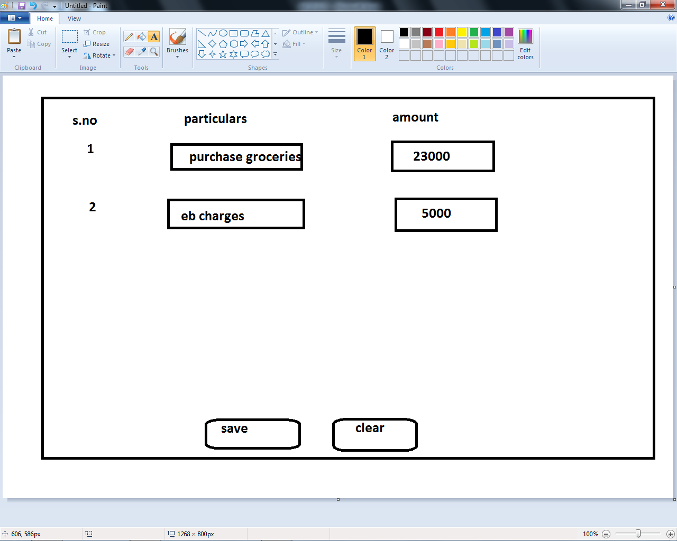

**WORKERS [PRASANTH]**

**workers application form in rms**

1. **hotel name**
2. **hotel address**
3. **mobile**
4. **email**
5. **name of the candidate**
6. **position applied for [waiter/manager/cashier/housekeeping/cook/server]**
7. **candidate address[doorno,streetname,areaname,pincode,state,district]**
8. **candidate mobile no, email**
9. **account no**
10. **experience [hotel name,no. of years,salary rcvd]**

**pARKING REGISTRATION FORM [PADMA]**

**1) PARKING CHARGE**

**2) TWO WHEELER NO.**

**3) OWNER NAME OF VEHICLE**

**4) OWNER MOBILE OF VEHICLE**

**5) NAME OF THE VEHICLE**

**6) MODE OF VEHICLE [ 2 WHEELER/ 3 WHEELER/4 WHEELER]**

**7) TOKEN**

**ONLINE ORDER DELIVERY [ID]**

1. **FOOD ORDER CONCERN [SWIGGY, ZOMATO,ETC,..]**
2. **CUSTOMER NAME**
3. **MOBILE**
4. **MAIL**
5. **TIMING**
6. **DATE**
7. **LOCATION**
8. **NATURE OF FOOD WITH QTY,PRICE**
9. **MODE OF PAYMENT [CASH/UPI/CARD]**
10. **DELIVERY CHARGES**
11. **PACKING CHARGES**
12. **GST**
13. **TOTAL**
14. **FOOD ORDER DELIVERY PERSON**
15. **FOOD ORDER DELIVERY PERSON WITH CONTACT**
16. **BILL NO**